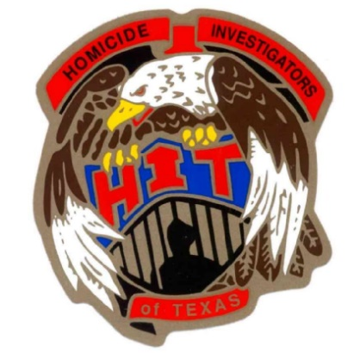
2020 HOMICIDE INVESTIGATORS OF TEXAS CONFERENCE
34th ANNUAL TRAINING ITINERARY

Monday, March 23rd

8:00 A.M - 12 noon Registration

12:30 P.M. – 1:00 P.M. Opening ceremony

1:00 P.M. – 3:00 P.M. Texas Equisearch – Tim Miller, Founder

3:00 P.M. – 5:00 P.M. What, Why and How – The Search for Murder Victims – Vi Shaffer

Tuesday, March 24th

08:00 A.M. - 12:00P.M. ADL – Hate Crimes – Symbols of Hate -Dena Marks – Houston ADL League

12:00 P.M. – 1:00 P.M. Lunch (on your own)

1:00 P.M. - 3:00 P.M. Serial Killers – Animals – Brian Harris, Retired Houston PD Homicide
3:00 P.M. – 5:00 P.M. Animal Crimes Investigations – Sgt. Charles Jantzen, Harris County Pct 5

Wednesday, March 25th

8:00 A.M. – 12:00 P.M. Targeted vs. Opportunistic Murder – Sgt Mike Miller, Houston PD Homicide
Connie Spence – Former Harris Co Prosecutor and Former Judge
12:00 P.M. – 1:00 P.M. Lunch – Provided by HIT

1:00 P.M. - 4:30 P.M. Targeted vs. Opportunistic Murder - Det. Eric Barnes – Dallas PD Homicide
4:30 P.M. -5:00 P.M. Case Exchange / Business Meeting

Thursday, March 26th

8:00 A.M. - 12:00 P.M. Beyond the Tape – Fixing the Murder Mistakes
Connie Spence, Former Harris County Prosecutor and Former Judge

12:00 P.M. ADJOURN – Have a safe trip Home

