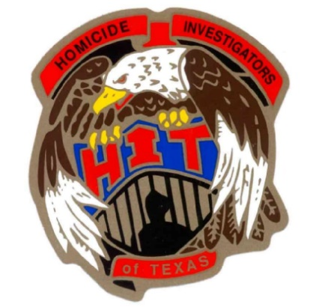
2020 HOMICIDE INVESTIGATORS OF TEXAS CONFERENCE
34th ANNUAL TRAINING ITINERARY
***TENTATIVE ITINERARY AND SUBJECT TO CHANGE***
Monday, March 23rd
8:00 A.M - 12 noon Registration

12:30 P.M. – 1:00 P.M. Opening ceremony

1:00 P.M. – 5:00 P.M. K-9 - Vi Schaffer
Texas Equisearch – Tim Miller, Founder

Tuesday, March 24th
08:00 A.M. - 10:00 A.M. ADL Hate Crimes

10:00 A.M. - 12:00P.M. Animal Crimes – The Precursor to Murder

12:00 P.M. – 1:00 P.M. Lunch (on your own)

1:00 P.M. - 4:00 P.M. Serial Killers – They are Killing to Tell Us
Brian Harris, Harris County Constable’s Office

Wednesday, March 25th
8:00 A.M. – 9:30 A.M. Feyntanol – Making the Case for Murder
9:30 A.M. – 10:00 A.M. Predictable and Un-Predictable Threats – Medical Center Murder
10:30 A.M. – 12:00 P.M. Johnathan Foster Kidnapping and Murder - The Battles Within a Homicide
Investigation and the Prosecution

Mike Miller, Houston PD Homicide
Connie Spence, Former Harris County Prosecutor and Former Judge Brian Harris, Chief Deputy, Harris County Constable’s Office Pct 5

12:00P.M. – 1:00 P.M. LUNCH (provided by HIT)

1:00 P.M. – 4:00 P.M. Child Abductions and Child Murders

4:00 P.M. -5:00 P.M. Case Exchange / Business Meeting

Thursday, March 26th
8:00 A.M. - 12:00 P.M. Beyond the Tape
Connie Spence, Former Harris County Prosecutor and Former Judge

12:00 P.M. ADJOURN – Have a safe trip Home

