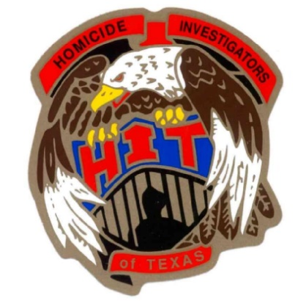

2019 HOMICIDE INVESTIGATORS OF TEXAS CONFERENCE
33rd ANNUAL TRAINING ITINERARY

Itinerary Subject to Change
Monday, March 25th
8:00 A.M - 12 noon Registration

12:30 P.M. – 1:00 P.M. Opening ceremony

1:00 P.M. – 5:00 P.M. Sutherland Springs Shooting
Texas Rangers

Tuesday, March 26th
08:00 A.M. - 12:00 P.M. Strangulation and Domestic Murders
Carvana Cloud, Harris County DA

12:00 P.M. – 1:00 P.M. Lunch (on your own)

1:00 P.M. - 5:00 P.M. Strangulation and Domestic Murders
Carvana Cloud, Harris County DA

Wednesday, March 27th
8:00 A.M. – 12:00 P.M. Homicide Hazards
Mike Alexander

12:00P.M. – 1:00 P.M. LUNCH (provided by HIT)

1:00 P.M. – 5:00 P.M. Homicide Hazards
Mike Alexander

4:00 P.M. -5:00 P.M. Case Exchange / Business Meeting

Thursday, March 28th
8:00 A.M. - 12:00 P.M. Cartel Killings
Javier Pena, Netflix show Narcos

12:00 P.M. ADJOURN

Thanks to Everyone, “Have a Safe Trip Home”

