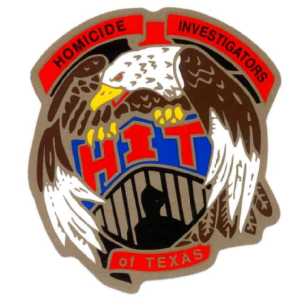

2018 HOMICIDE INVESTIGATORS OF TEXAS CONFERENCE
32nd ANNUAL TRAINING ITINERARY

Monday, March 19
8:00 A.M - 12 noon Registration

12:30 P.M. – 1:00 P.M. Opening ceremony

1:00 P.M. – 5:00 P.M. Miranda and Monologue
Brian Harris, Chief Deputy, Pct. 5, Harris County

Tuesday, March 20th
08:00 A.M. - 12:00 P.M. Dark Web
James Ward, Analyst, Houston Police Department, Homicide Division

12:00 P.M. – 1:00 P.M. Lunch (on your own)

1:00 P.M. - 5:00 P.M. Dark Web
James Ward, Analyst, Houston Police Department, Homicide Division

Wednesday, March 21st
8:00 A.M. – 12:00 P.M. MS13 Crimes and Recognition
Sgt. Jose Duran, Houston Police Department, Major Crimes Division/Multi Agency Gang Task Force

12:00P.M. – 1:00 P.M. LUNCH (provided by HIT)

1:00 P.M. – 5:00 P.M. MS13 Crimes and Recognition
Sgt. Jose Duran, Houston Police Department, Major Crimes Division/Multi Agency Gang Task Force

4:00 P.M. -5:00 P.M. Case Exchange / Business Meeting

Thursday, March 22nd
8:00 A.M. - 12:00 P.M. Legal Updates from the Defense Side
Murray Newman, Former prosecutor for the Harris County DA Office who is now a Defense Attorney

12:00 P.M. ADJOURN

Thanks to Everyone, “Have a Safe Trip Home”

