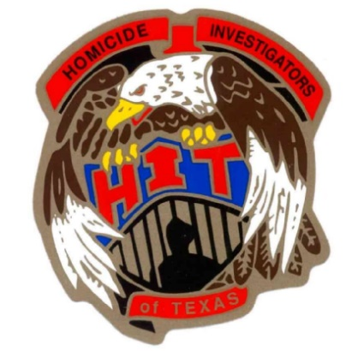

2024 HOMICIDE INVESTIGATORS OF TEXAS CONFERENCE
36th ANNUAL TRAINING ITINERARY

Monday, March 25th
8:00 A.M - 12 noon Registration

12:30 P.M. – 1:00 P.M. Opening ceremony

1:00 P.M. – 5:00 P.M. Interpretating Crime Scenes and Working as a Team
Jason White – Tulsa Oklahoma PD Homicide Unit Numerous appearances on First 48)

Tuesday, March 26th
08:00 A.M. - 12:00 P.M. Multi - Jurisdictional Homicide Investigations
Captain Clair Barnes (Retired Texas Ranger)

12:00 P.M. – 1:00 P.M. Lunch (on your own)

1:00 P.M. – 5:00 P.M. Bonnie Harkey “Pecan Queen” Homicide Case Study
John Wilkerson (TMPA)

Wednesday, March 27th
8:00 A.M. – 12:00 P.M. Equivocal Death Investigations
Ashleigh Berg (Denton County S.O Forensics)

12:00P.M. – 1:00 P.M. Lunch (on your own)

1:00 P.M. – 4:00 P.M. Serial Killer “John Williams” Presentation
Larry Hallmark (Retired Grapevine P.D. – Current Denton County S.O. CID Sgt.

4:30 P.M. -5:00 P.M. Business Meeting

Thursday, March 28th
8:00 A.M. - 12:00 P.M. Jeffery Dahmer and Kyle Rittenhouse Presentation
Steve Spingola (Retired Minneapolis PD (Numerous Appearances on Cold Justice)

12:00 P.M. ADJOURN

Thanks to Everyone, “Have a Safe Trip Home”

